1 run...

Downloading: 100%

411/411 [00:00<00:00, 12.1kB/s]

Downloading: 100%

263M/263M [00:05<00:00, 45.5MB/s]

training 1 epoch...

1196.306809425354 seconds used......

1 training finished! average train loss: 0.8337175964904933

total clf loss: 526.5299174152315 total adv loss: 305.3304410269484

evaluating...

Confusion matrix, without normalization

[[ 382 341 299]

[ 171 5006 230]

[ 160 344 10261]]

Normalized confusion matrix

[[0.37377691 0.33365949 0.2925636 ]

[0.03162567 0.92583688 0.04253745]

[0.01486298 0.03195541 0.95318161]]

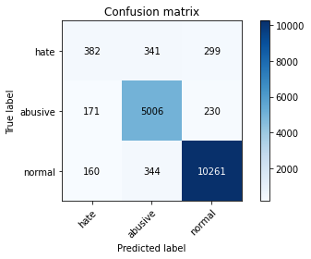

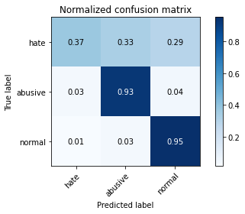

precision recall f1-score support

hate 0.54 0.37 0.44 1022

abusive 0.88 0.93 0.90 5407

normal 0.95 0.95 0.95 10765

accuracy 0.91 17194

macro avg 0.79 0.75 0.76 17194

weighted avg 0.90 0.91 0.91 17194

average eval_loss: 0.28217930663377044, accuracy: 0.9101430731650576

training 2 epoch...

1195.8726692199707 seconds used......

2 training finished! average train loss: 0.6618629776902737

total clf loss: 419.1849181652069 total adv loss: 241.79809199273586

evaluating...

Confusion matrix, without normalization

[[ 341 392 289]

[ 148 5063 196]

[ 145 441 10179]]

Normalized confusion matrix

[[0.33365949 0.38356164 0.28277886]

[0.02737193 0.93637877 0.03624931]

[0.01346958 0.04096609 0.94556433]]

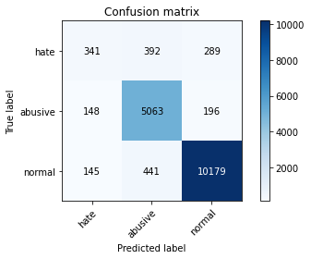

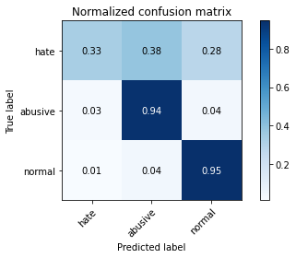

precision recall f1-score support

hate 0.54 0.33 0.41 1022

abusive 0.86 0.94 0.90 5407

normal 0.95 0.95 0.95 10765

accuracy 0.91 17194

macro avg 0.78 0.74 0.75 17194

weighted avg 0.90 0.91 0.90 17194

average eval_loss: 0.29262574724419865, accuracy: 0.9063045248342445

training 3 epoch...

1195.4433200359344 seconds used......

3 training finished! average train loss: 0.5215781328631592

total clf loss: 334.7575931865722 total adv loss: 188.33749079913832

evaluating...

Confusion matrix, without normalization

[[ 463 301 258]

[ 340 4866 201]

[ 347 401 10017]]

Normalized confusion matrix

[[0.45303327 0.29452055 0.25244618]

[0.06288145 0.89994452 0.03717403]

[0.03223409 0.03725035 0.93051556]]

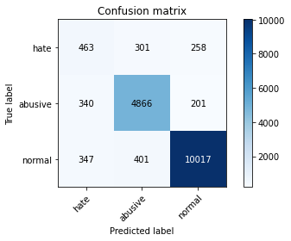

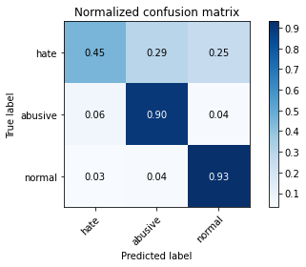

precision recall f1-score support

hate 0.40 0.45 0.43 1022

abusive 0.87 0.90 0.89 5407

normal 0.96 0.93 0.94 10765

accuracy 0.89 17194

macro avg 0.74 0.76 0.75 17194

weighted avg 0.90 0.89 0.89 17194

average eval_loss: 0.3282293127069986, accuracy: 0.892520646737234

training 4 epoch...

1195.8310086727142 seconds used......

4 training finished! average train loss: 0.3912987344388924

total clf loss: 250.2523722825572 total adv loss: 141.73955107762595

evaluating...

Confusion matrix, without normalization

[[ 436 335 251]

[ 273 4950 184]

[ 373 461 9931]]

Normalized confusion matrix

[[0.42661448 0.32778865 0.24559687]

[0.05049011 0.91547993 0.03402996]

[0.03464933 0.04282397 0.92252671]]

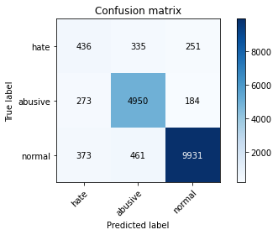

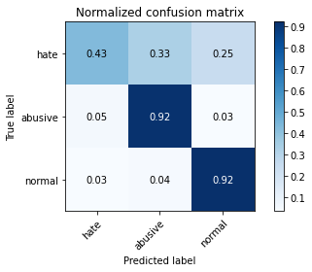

precision recall f1-score support

hate 0.40 0.43 0.41 1022

abusive 0.86 0.92 0.89 5407

normal 0.96 0.92 0.94 10765

accuracy 0.89 17194

macro avg 0.74 0.75 0.75 17194

weighted avg 0.89 0.89 0.89 17194

average eval_loss: 0.35962533675090863, accuracy: 0.890834011864604

training 5 epoch...

1196.0135462284088 seconds used......

5 training finished! average train loss: 0.28608563443839746

total clf loss: 179.85756771685556 total adv loss: 105.18161888189206

evaluating...

Confusion matrix, without normalization

[[ 369 368 285]

[ 228 4938 241]

[ 271 398 10096]]

Normalized confusion matrix

[[0.36105675 0.36007828 0.27886497]

[0.04216756 0.91326059 0.04457185]

[0.02517418 0.03697167 0.93785416]]

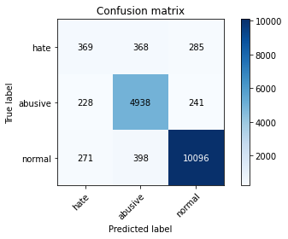

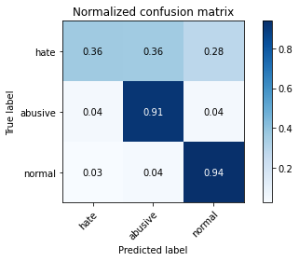

precision recall f1-score support

hate 0.43 0.36 0.39 1022

abusive 0.87 0.91 0.89 5407

normal 0.95 0.94 0.94 10765

accuracy 0.90 17194

macro avg 0.75 0.74 0.74 17194

weighted avg 0.89 0.90 0.89 17194

average eval_loss: 0.4071612512216318, accuracy: 0.8958357566592997

2 run...

training 1 epoch...

1195.755895614624 seconds used......

1 training finished! average train loss: 0.8357546477854426

total clf loss: 523.8728476464748 total adv loss: 308.04824618436396

evaluating...

Confusion matrix, without normalization

[[ 320 359 343]

[ 136 5042 229]

[ 81 392 10292]]

Normalized confusion matrix

[[0.31311155 0.35127202 0.33561644]

[0.02515258 0.93249491 0.04235251]

[0.00752438 0.03641431 0.95606131]]

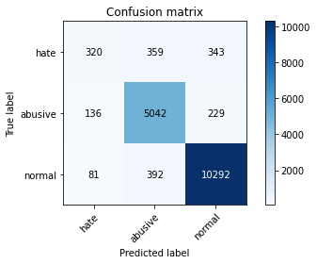

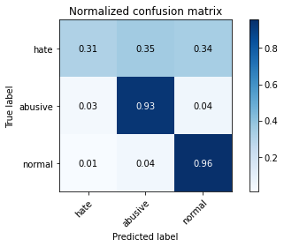

precision recall f1-score support

hate 0.60 0.31 0.41 1022

abusive 0.87 0.93 0.90 5407

normal 0.95 0.96 0.95 10765

accuracy 0.91 17194

macro avg 0.80 0.73 0.75 17194

weighted avg 0.90 0.91 0.90 17194

average eval_loss: 0.29107492979356026, accuracy: 0.9104338722810282

training 2 epoch...

1196.5457165241241 seconds used......

2 training finished! average train loss: 0.6620528408793236

total clf loss: 417.9665478542447 total adv loss: 242.53676369879395

evaluating...

Confusion matrix, without normalization

[[ 406 351 265]

[ 211 5034 162]

[ 197 472 10096]]

Normalized confusion matrix

[[0.39726027 0.34344423 0.2592955 ]

[0.03902349 0.93101535 0.02996116]

[0.01830005 0.0438458 0.93785416]]

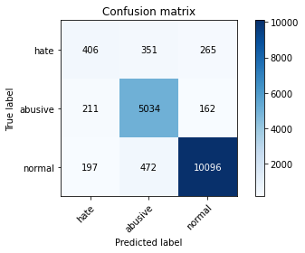

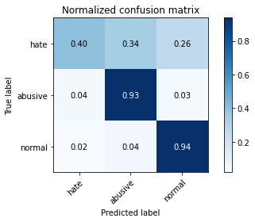

precision recall f1-score support

hate 0.50 0.40 0.44 1022

abusive 0.86 0.93 0.89 5407

normal 0.96 0.94 0.95 10765

accuracy 0.90 17194

macro avg 0.77 0.76 0.76 17194

weighted avg 0.90 0.90 0.90 17194

average eval_loss: 0.29538601288615274, accuracy: 0.90357101314412

training 3 epoch...

1196.5629441738129 seconds used......

3 training finished! average train loss: 0.5192773191980701

total clf loss: 332.3613565210253 total adv loss: 187.96645322191762

evaluating...

Confusion matrix, without normalization

[[ 453 338 231]

[ 249 4993 165]

[ 414 505 9846]]

Normalized confusion matrix

[[0.44324853 0.33072407 0.2260274 ]

[0.04605141 0.92343259 0.030516 ]

[0.03845797 0.04691129 0.91463075]]

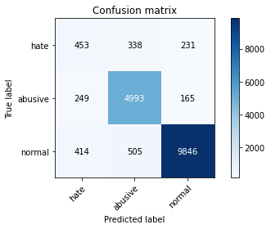

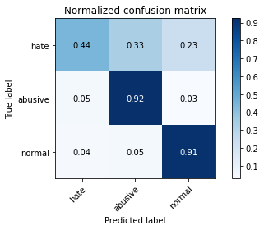

precision recall f1-score support

hate 0.41 0.44 0.42 1022

abusive 0.86 0.92 0.89 5407

normal 0.96 0.91 0.94 10765

accuracy 0.89 17194

macro avg 0.74 0.76 0.75 17194

weighted avg 0.90 0.89 0.89 17194

average eval_loss: 0.33219523320710936, accuracy: 0.8893800162847505

training 4 epoch...

1197.3425586223602 seconds used......

4 training finished! average train loss: 0.39038023800873184

total clf loss: 247.60580767784268 total adv loss: 142.4364186633611

evaluating...

Confusion matrix, without normalization

[[ 485 274 263]

[ 439 4742 226]

[ 321 408 10036]]

Normalized confusion matrix

[[0.47455969 0.26810176 0.25733855]

[0.08119105 0.87701128 0.04179767]

[0.02981886 0.0379006 0.93228054]]

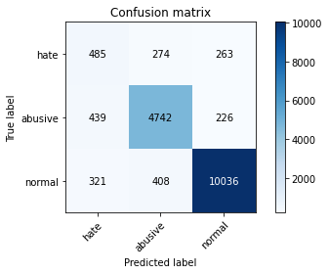

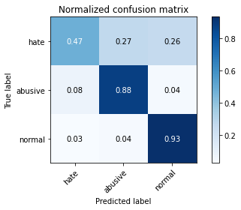

precision recall f1-score support

hate 0.39 0.47 0.43 1022

abusive 0.87 0.88 0.88 5407

normal 0.95 0.93 0.94 10765

accuracy 0.89 17194

macro avg 0.74 0.76 0.75 17194

weighted avg 0.90 0.89 0.89 17194

average eval_loss: 0.38305277360852286, accuracy: 0.8876933814121205

training 5 epoch...

1198.665658712387 seconds used......

5 training finished! average train loss: 0.2808137848280927

total clf loss: 174.62279276247136 total adv loss: 104.2036051719333

evaluating...

Confusion matrix, without normalization

[[ 492 305 225]

[ 408 4825 174]

[ 532 425 9808]]

Normalized confusion matrix

[[0.481409 0.29843444 0.22015656]

[0.07545774 0.89236175 0.03218051]

[0.04941941 0.0394798 0.91110079]]

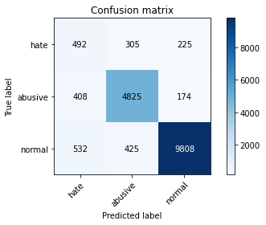

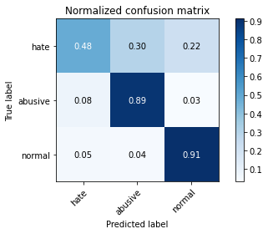

precision recall f1-score support

hate 0.34 0.48 0.40 1022

abusive 0.87 0.89 0.88 5407

normal 0.96 0.91 0.94 10765

accuracy 0.88 17194

macro avg 0.72 0.76 0.74 17194

weighted avg 0.90 0.88 0.89 17194

average eval_loss: 0.44993086489848794, accuracy: 0.8796673258113296

1 run...

Downloading: 100%

411/411 [00:00<00:00, 13.6kB/s]

Downloading: 100%

263M/263M [00:08<00:00, 32.2MB/s]

training 1 epoch...

1206.0087223052979 seconds used......

1 training finished! average train loss: 0.8447327855482829

total clf loss: 532.7742954790592 total adv loss: 309.72061270754784

evaluating...

Confusion matrix, without normalization

[[ 384 325 313]

[ 175 4983 249]

[ 165 363 10237]]

Normalized confusion matrix

[[0.37573386 0.31800391 0.30626223]

[0.03236545 0.92158313 0.04605141]

[0.01532745 0.03372039 0.95095216]]

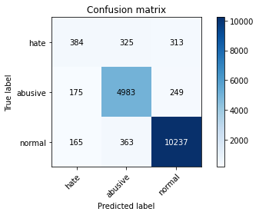

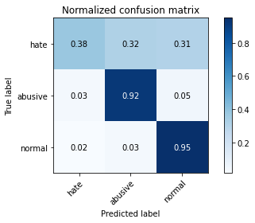

precision recall f1-score support

hate 0.53 0.38 0.44 1022

abusive 0.88 0.92 0.90 5407

normal 0.95 0.95 0.95 10765

accuracy 0.91 17194

macro avg 0.79 0.75 0.76 17194

weighted avg 0.90 0.91 0.90 17194

average eval_loss: 0.28599359325111606, accuracy: 0.9075258811213214

training 2 epoch...

1205.6793344020844 seconds used......

2 training finished! average train loss: 0.6540874465371419

total clf loss: 416.59786693938076 total adv loss: 237.78870502766222

evaluating...

Confusion matrix, without normalization

[[ 399 327 296]

[ 201 5012 194]

[ 167 399 10199]]

Normalized confusion matrix

[[0.39041096 0.31996086 0.28962818]

[0.03717403 0.92694655 0.03587942]

[0.01551324 0.03706456 0.9474222 ]]

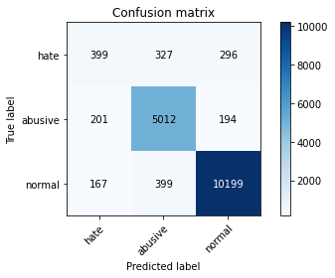

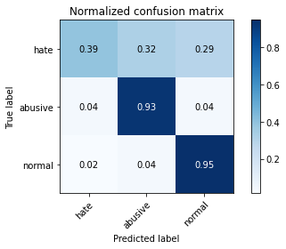

precision recall f1-score support

hate 0.52 0.39 0.45 1022

abusive 0.87 0.93 0.90 5407

normal 0.95 0.95 0.95 10765

accuracy 0.91 17194

macro avg 0.78 0.75 0.77 17194

weighted avg 0.90 0.91 0.90 17194

average eval_loss: 0.2832696346371153, accuracy: 0.9078748400604862

training 3 epoch...

1205.8755915164948 seconds used......

3 training finished! average train loss: 0.533846962765471

total clf loss: 340.1912955008447 total adv loss: 193.98798118991544

evaluating...

Confusion matrix, without normalization

[[ 366 362 294]

[ 175 4969 263]

[ 238 333 10194]]

Normalized confusion matrix

[[0.35812133 0.35420744 0.28767123]

[0.03236545 0.9189939 0.04864065]

[0.02210869 0.03093358 0.94695773]]

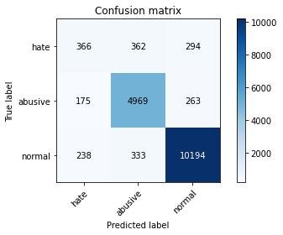

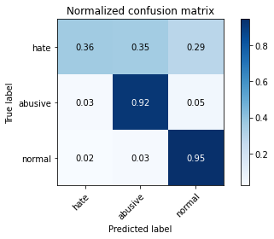

precision recall f1-score support

hate 0.47 0.36 0.41 1022

abusive 0.88 0.92 0.90 5407

normal 0.95 0.95 0.95 10765

accuracy 0.90 17194

macro avg 0.77 0.74 0.75 17194

weighted avg 0.90 0.90 0.90 17194

average eval_loss: 0.3031326569356891, accuracy: 0.903163894381761

training 4 epoch...

1206.0947844982147 seconds used......

4 training finished! average train loss: 0.39137421033817654

total clf loss: 248.8372925571166 total adv loss: 142.4985652785981

evaluating...

Confusion matrix, without normalization

[[ 418 334 270]

[ 256 4929 222]

[ 369 411 9985]]

Normalized confusion matrix

[[0.40900196 0.32681018 0.26418787]

[0.04734603 0.91159608 0.04105789]

[0.03427775 0.03817928 0.92754296]]

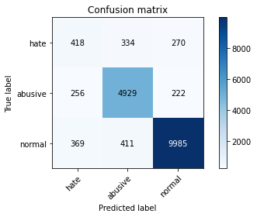

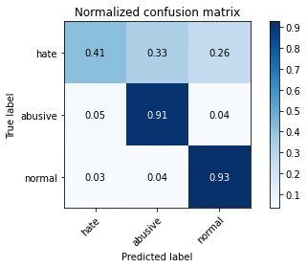

precision recall f1-score support

hate 0.40 0.41 0.40 1022

abusive 0.87 0.91 0.89 5407

normal 0.95 0.93 0.94 10765

accuracy 0.89 17194

macro avg 0.74 0.75 0.74 17194

weighted avg 0.89 0.89 0.89 17194

average eval_loss: 0.3693197239255316, accuracy: 0.891706409212516

training 5 epoch...

1205.4227125644684 seconds used......

5 training finished! average train loss: 0.2851670625977371

total clf loss: 178.39090949762613 total adv loss: 105.28848171018763

evaluating...

Confusion matrix, without normalization

[[ 524 270 228]

[ 517 4704 186]

[ 729 346 9690]]

Normalized confusion matrix

[[0.51272016 0.26418787 0.22309198]

[0.09561679 0.86998335 0.03439985]

[0.06771946 0.0321412 0.90013934]]

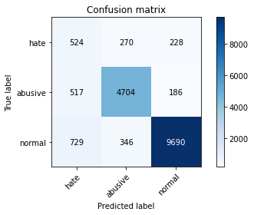

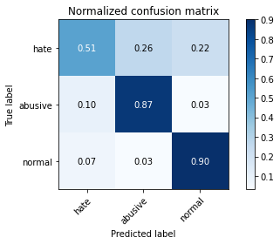

precision recall f1-score support

hate 0.30 0.51 0.38 1022

abusive 0.88 0.87 0.88 5407

normal 0.96 0.90 0.93 10765

accuracy 0.87 17194

macro avg 0.71 0.76 0.73 17194

weighted avg 0.90 0.87 0.88 17194

average eval_loss: 0.45184315716371287, accuracy: 0.867628242410143

training 6 epoch...

1204.6543209552765 seconds used......

6 training finished! average train loss: 0.2289053849892826

total clf loss: 139.417599444394 total adv loss: 86.40467301977333

evaluating...

Confusion matrix, without normalization

[[ 478 302 242]

[ 429 4740 238]

[ 577 367 9821]]

Normalized confusion matrix

[[0.46771037 0.29549902 0.23679061]

[0.07934159 0.87664139 0.04401701]

[0.05359963 0.03409196 0.91230841]]

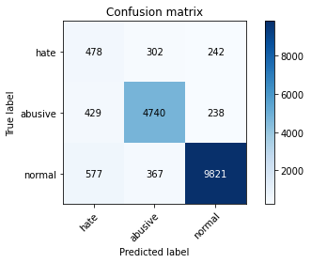

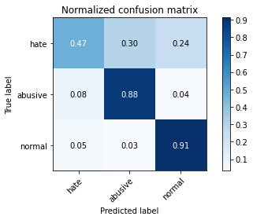

precision recall f1-score support

hate 0.32 0.47 0.38 1022

abusive 0.88 0.88 0.88 5407

normal 0.95 0.91 0.93 10765

accuracy 0.87 17194

macro avg 0.72 0.75 0.73 17194

weighted avg 0.89 0.87 0.88 17194

average eval_loss: 0.5105993967416674, accuracy: 0.8746655810166337

training 7 epoch...

1205.2132861614227 seconds used......

7 training finished! average train loss: 0.1983306202572351

total clf loss: 117.71140091656707 total adv loss: 76.40578244283097

evaluating...

Confusion matrix, without normalization

[[ 432 308 282]

[ 329 4826 252]

[ 379 340 10046]]

Normalized confusion matrix

[[0.42270059 0.30136986 0.27592955]

[0.06084705 0.8925467 0.04660625]

[0.03520669 0.03158384 0.93320948]]

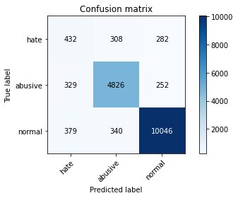

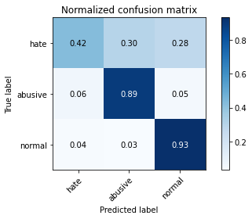

precision recall f1-score support

hate 0.38 0.42 0.40 1022

abusive 0.88 0.89 0.89 5407

normal 0.95 0.93 0.94 10765

accuracy 0.89 17194

macro avg 0.74 0.75 0.74 17194

weighted avg 0.89 0.89 0.89 17194

average eval_loss: 0.5662841625235837, accuracy: 0.8900779341630801

training 8 epoch...

1206.0218296051025 seconds used......

8 training finished! average train loss: 0.1550562441003112

total clf loss: 89.67432755196933 total adv loss: 60.91119455084845

evaluating...

Confusion matrix, without normalization

[[ 429 278 315]

[ 404 4699 304]

[ 218 332 10215]]

Normalized confusion matrix

[[0.41976517 0.27201566 0.30821918]

[0.07471796 0.86905863 0.05622341]

[0.02025081 0.03084069 0.9489085 ]]

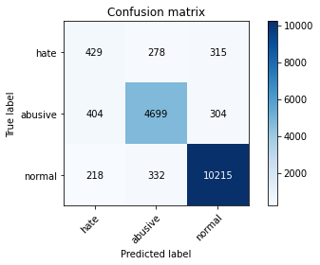

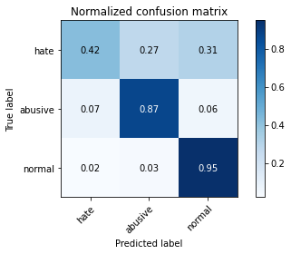

precision recall f1-score support

hate 0.41 0.42 0.41 1022

abusive 0.89 0.87 0.88 5407

normal 0.94 0.95 0.95 10765

accuracy 0.89 17194

macro avg 0.75 0.75 0.75 17194

weighted avg 0.89 0.89 0.89 17194

average eval_loss: 0.5943557642039851, accuracy: 0.8923461672676515

training 9 epoch...

1204.3240678310394 seconds used......

9 training finished! average train loss: 0.14699216733151577

total clf loss: 84.4328871746402 total adv loss: 58.03221443818438

evaluating...

Confusion matrix, without normalization

[[ 462 272 288]

[ 434 4717 256]

[ 437 333 9995]]

Normalized confusion matrix

[[0.45205479 0.26614481 0.28180039]

[0.08026632 0.87238765 0.04734603]

[0.04059452 0.03093358 0.9284719 ]]

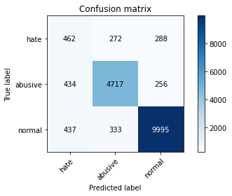

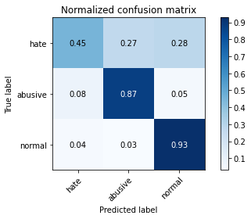

precision recall f1-score support

hate 0.35 0.45 0.39 1022

abusive 0.89 0.87 0.88 5407

normal 0.95 0.93 0.94 10765

accuracy 0.88 17194

macro avg 0.73 0.75 0.74 17194

weighted avg 0.89 0.88 0.89 17194

average eval_loss: 0.575530575846862, accuracy: 0.8825171571478423

training 10 epoch...

1203.8614811897278 seconds used......

10 training finished! average train loss: 0.14046297064468385

total clf loss: 78.96286741935182 total adv loss: 56.31431226639688

evaluating...

Confusion matrix, without normalization

[[ 427 327 268]

[ 295 4886 226]

[ 429 386 9950]]

Normalized confusion matrix

[[0.41780822 0.31996086 0.26223092]

[0.05455891 0.90364343 0.04179767]

[0.03985137 0.03585694 0.92429169]]

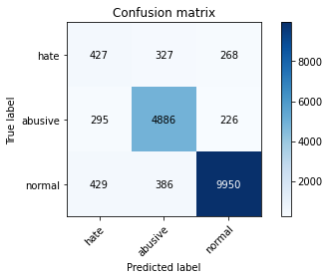

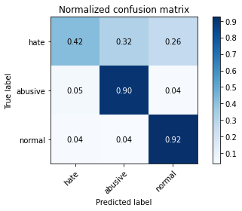

precision recall f1-score support

hate 0.37 0.42 0.39 1022

abusive 0.87 0.90 0.89 5407

normal 0.95 0.92 0.94 10765

accuracy 0.89 17194

macro avg 0.73 0.75 0.74 17194

weighted avg 0.89 0.89 0.89 17194

average eval_loss: 0.6317487222041669, accuracy: 0.8876933814121205

2 run...

training 1 epoch...

alpha= 0.2

1 run...

Downloading: 100%

411/411 [00:00<00:00, 12.2kB/s]

Downloading: 100%

263M/263M [00:12<00:00, 17.4MB/s]

training 1 epoch...

1202.1908965110779 seconds used......

1 training finished! average train loss: 0.42668974362969225

total clf loss: 520.514458078891 total adv loss: 307.45175748784095

evaluating...

Confusion matrix, without normalization

[[ 197 512 313]

[ 31 5168 208]

[ 41 450 10274]]

Normalized confusion matrix

[[0.1927593 0.50097847 0.30626223]

[0.00573331 0.95579804 0.03846865]

[0.00380864 0.04180214 0.95438922]]

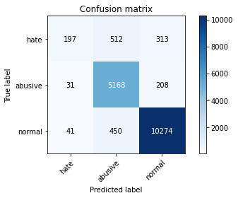

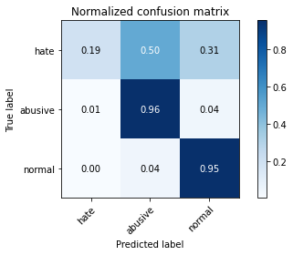

precision recall f1-score support

hate 0.73 0.19 0.31 1022

abusive 0.84 0.96 0.90 5407

normal 0.95 0.95 0.95 10765

accuracy 0.91 17194

macro avg 0.84 0.70 0.72 17194

weighted avg 0.90 0.91 0.90 17194

average eval_loss: 0.2863398386771942, accuracy: 0.9095614749331162

training 2 epoch...

1201.3977925777435 seconds used......

2 training finished! average train loss: 0.3350551782170436

total clf loss: 407.87384168058634 total adv loss: 245.70710533950478

evaluating...

Confusion matrix, without normalization

[[ 495 255 272]

[ 391 4780 236]

[ 319 295 10151]]

Normalized confusion matrix

[[0.48434442 0.24951076 0.26614481]

[0.07231367 0.88403921 0.04364712]

[0.02963307 0.02740362 0.94296331]]

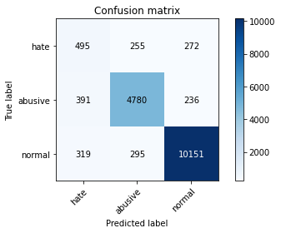

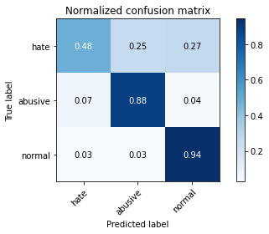

precision recall f1-score support

hate 0.41 0.48 0.44 1022

abusive 0.90 0.88 0.89 5407

normal 0.95 0.94 0.95 10765

accuracy 0.90 17194

macro avg 0.75 0.77 0.76 17194

weighted avg 0.90 0.90 0.90 17194

average eval_loss: 0.2970784015736954, accuracy: 0.8971734325927649

training 3 epoch...

1201.719616651535 seconds used......

3 training finished! average train loss: 0.24588862137767947

total clf loss: 296.9939991394058 total adv loss: 191.99039992596954

evaluating...

Confusion matrix, without normalization

[[ 389 359 274]

[ 218 4932 257]

[ 263 363 10139]]

Normalized confusion matrix

[[0.38062622 0.35127202 0.26810176]

[0.04031811 0.91215092 0.04753098]

[0.02443103 0.03372039 0.94184858]]

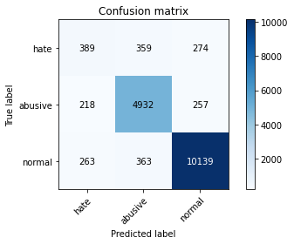

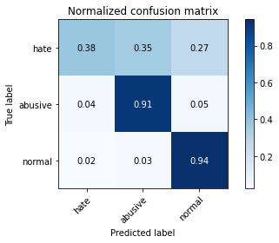

precision recall f1-score support

hate 0.45 0.38 0.41 1022

abusive 0.87 0.91 0.89 5407

normal 0.95 0.94 0.95 10765

accuracy 0.90 17194

macro avg 0.76 0.74 0.75 17194

weighted avg 0.90 0.90 0.90 17194

average eval_loss: 0.33754281415062587, accuracy: 0.8991508665813656

training 4 epoch...

1201.8121309280396 seconds used......

4 training finished! average train loss: 0.16593175215845998

total clf loss: 197.68443064950407 total adv loss: 143.2323964574607

evaluating...

Confusion matrix, without normalization

[[ 492 287 243]

[ 388 4764 255]

[ 523 371 9871]]

Normalized confusion matrix

[[0.481409 0.28082192 0.23776908]

[0.07175883 0.88108008 0.04716109]

[0.04858337 0.03446354 0.91695309]]

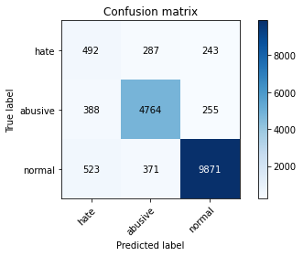

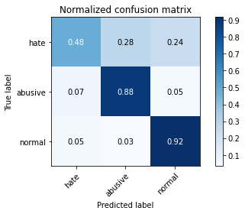

precision recall f1-score support

hate 0.35 0.48 0.41 1022

abusive 0.88 0.88 0.88 5407

normal 0.95 0.92 0.93 10765

accuracy 0.88 17194

macro avg 0.73 0.76 0.74 17194

weighted avg 0.89 0.88 0.89 17194

average eval_loss: 0.4149232185965534, accuracy: 0.8797836454577178

training 5 epoch...

1201.6788816452026 seconds used......

5 training finished! average train loss: 0.11572996793277944

total clf loss: 136.44888521323446 total adv loss: 107.03395361792354

evaluating...

Confusion matrix, without normalization

[[ 446 321 255]

[ 384 4809 214]

[ 388 397 9980]]

Normalized confusion matrix

[[0.43639922 0.31409002 0.24951076]

[0.07101905 0.88940263 0.03957832]

[0.03604273 0.03687877 0.9270785 ]]

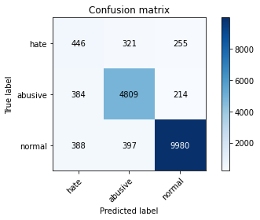

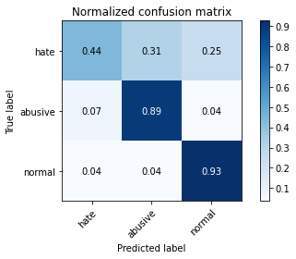

precision recall f1-score support

hate 0.37 0.44 0.40 1022

abusive 0.87 0.89 0.88 5407

normal 0.96 0.93 0.94 10765

accuracy 0.89 17194

macro avg 0.73 0.75 0.74 17194

weighted avg 0.89 0.89 0.89 17194

average eval_loss: 0.5157956051902147, accuracy: 0.8860649063626846

training 6 epoch...

1201.6472284793854 seconds used......

6 training finished! average train loss: 0.0908072229990373

total clf loss: 106.77364850867889 total adv loss: 85.43701653793687

evaluating...

Confusion matrix, without normalization

[[ 435 312 275]

[ 372 4783 252]

[ 311 392 10062]]

Normalized confusion matrix

[[0.42563601 0.30528376 0.26908023]

[0.0687997 0.88459404 0.04660625]

[0.02888992 0.03641431 0.93469577]]

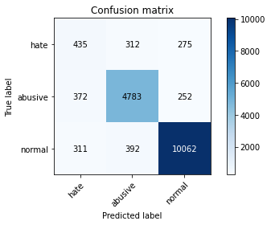

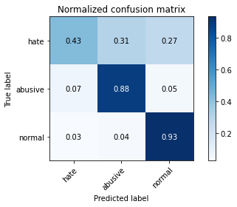

precision recall f1-score support

hate 0.39 0.43 0.41 1022

abusive 0.87 0.88 0.88 5407

normal 0.95 0.93 0.94 10765

accuracy 0.89 17194

macro avg 0.74 0.75 0.74 17194

weighted avg 0.89 0.89 0.89 17194

average eval_loss: 0.4935056726367018, accuracy: 0.8886820984064209

training 7 epoch...

1202.1648046970367 seconds used......

7 training finished! average train loss: 0.07760786691117592

total clf loss: 91.12613600271288 total adv loss: 73.6549712948763

evaluating...

Confusion matrix, without normalization

[[ 386 343 293]

[ 256 4883 268]

[ 254 365 10146]]

Normalized confusion matrix

[[0.3776908 0.33561644 0.28669276]

[0.04734603 0.90308859 0.04956538]

[0.02359498 0.03390618 0.94249884]]

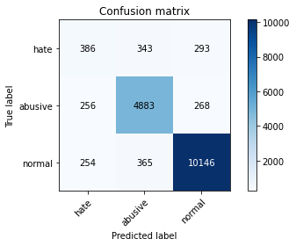

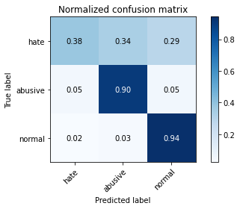

precision recall f1-score support

hate 0.43 0.38 0.40 1022

abusive 0.87 0.90 0.89 5407

normal 0.95 0.94 0.95 10765

accuracy 0.90 17194

macro avg 0.75 0.74 0.75 17194

weighted avg 0.89 0.90 0.89 17194

average eval_loss: 0.5619003560878661, accuracy: 0.8965336745376294

training 8 epoch...

1202.193295955658 seconds used......

8 training finished! average train loss: 0.06785838792726666

total clf loss: 79.62564807629678 total adv loss: 64.6659636714594

evaluating...

Confusion matrix, without normalization

[[ 447 280 295]

[ 428 4659 320]

[ 350 326 10089]]

Normalized confusion matrix

[[0.43737769 0.2739726 0.28864971]

[0.07915665 0.86166081 0.05918254]

[0.03251277 0.03028333 0.9372039 ]]

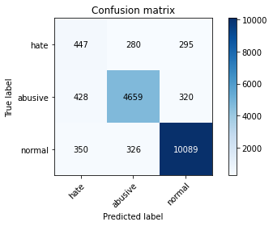

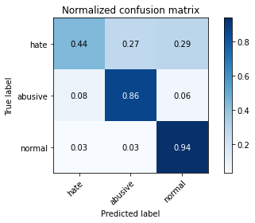

precision recall f1-score support

hate 0.36 0.44 0.40 1022

abusive 0.88 0.86 0.87 5407

normal 0.94 0.94 0.94 10765

accuracy 0.88 17194

macro avg 0.73 0.75 0.74 17194

weighted avg 0.89 0.88 0.89 17194

average eval_loss: 0.592876888976871, accuracy: 0.8837385134349192

training 9 epoch...

1202.8246657848358 seconds used......

9 training finished! average train loss: 0.0641944676888062

total clf loss: 75.05789482526598 total adv loss: 62.5167948780545

evaluating...

Confusion matrix, without normalization

[[ 491 287 244]

[ 422 4760 225]

[ 467 391 9907]]

Normalized confusion matrix

[[0.48043053 0.28082192 0.23874755]

[0.07804698 0.8803403 0.04161272]

[0.04338133 0.03632141 0.92029726]]

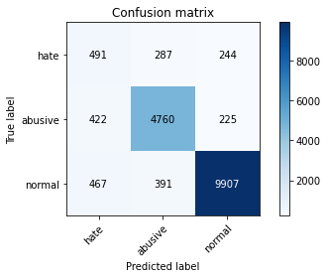

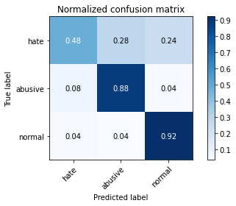

precision recall f1-score support

hate 0.36 0.48 0.41 1022

abusive 0.88 0.88 0.88 5407

normal 0.95 0.92 0.94 10765

accuracy 0.88 17194

macro avg 0.73 0.76 0.74 17194

weighted avg 0.89 0.88 0.89 17194

average eval_loss: 0.5866917306505859, accuracy: 0.881586599976736

training 10 epoch...

alpha = 10

1 run...

Downloading: 100%

411/411 [00:00<00:00, 14.0kB/s]

Downloading: 100%

263M/263M [00:05<00:00, 45.6MB/s]

training 1 epoch...

1194.692360162735 seconds used......

1 training finished! average train loss: 2.677898006104042

total clf loss: 555.2657437697053 total adv loss: 309.7387131936848

evaluating...

Confusion matrix, without normalization

[[ 323 354 345]

[ 139 4994 274]

[ 63 367 10335]]

Normalized confusion matrix

[[0.31604697 0.34637965 0.33757339]

[0.02570742 0.92361753 0.05067505]

[0.0058523 0.03409196 0.96005574]]

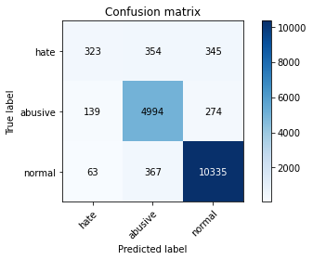

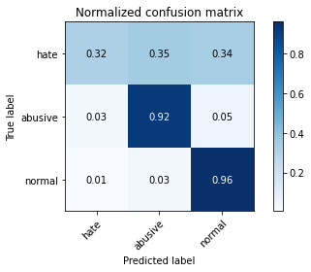

precision recall f1-score support

hate 0.62 0.32 0.42 1022

abusive 0.87 0.92 0.90 5407

normal 0.94 0.96 0.95 10765

accuracy 0.91 17194

macro avg 0.81 0.73 0.76 17194

weighted avg 0.90 0.91 0.90 17194

average eval_loss: 0.2847639924716638, accuracy: 0.91031755263464

training 2 epoch...

1194.1037621498108 seconds used......

2 training finished! average train loss: 2.1038001350228215

total clf loss: 443.30407106503844 total adv loss: 242.62793121440336

evaluating...

Confusion matrix, without normalization

[[ 419 283 320]

[ 256 4892 259]

[ 131 338 10296]]

Normalized confusion matrix

[[0.40998043 0.27690802 0.31311155]

[0.04734603 0.9047531 0.04790087]

[0.01216907 0.03139805 0.95643288]]

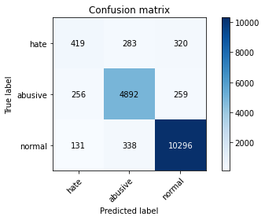

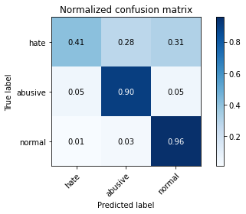

precision recall f1-score support

hate 0.52 0.41 0.46 1022

abusive 0.89 0.90 0.90 5407

normal 0.95 0.96 0.95 10765

accuracy 0.91 17194

macro avg 0.78 0.76 0.77 17194

weighted avg 0.90 0.91 0.90 17194

average eval_loss: 0.2948305917665536, accuracy: 0.9077003605909038

training 3 epoch...

1193.073667049408 seconds used......

3 training finished! average train loss: 1.6652470976523945

total clf loss: 379.0666875001043 total adv loss: 189.23303540493362

evaluating...

Confusion matrix, without normalization

[[ 410 319 293]

[ 258 4908 241]

[ 224 366 10175]]

Normalized confusion matrix

[[0.40117417 0.31213307 0.28669276]

[0.04771592 0.90771222 0.04457185]

[0.02080817 0.03399907 0.94519275]]

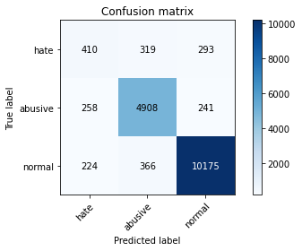

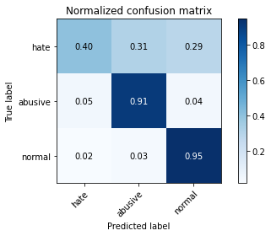

precision recall f1-score support

hate 0.46 0.40 0.43 1022

abusive 0.88 0.91 0.89 5407

normal 0.95 0.95 0.95 10765

accuracy 0.90 17194

macro avg 0.76 0.75 0.76 17194

weighted avg 0.90 0.90 0.90 17194

average eval_loss: 0.3102117446402824, accuracy: 0.9010701407467722

training 4 epoch...

1194.4876930713654 seconds used......

4 training finished! average train loss: 1.2899597053555363

total clf loss: 328.2657996304333 total adv loss: 143.12392379174707

evaluating...

Confusion matrix, without normalization

[[ 492 260 270]

[ 440 4712 255]

[ 369 322 10074]]

Normalized confusion matrix

[[0.481409 0.25440313 0.26418787]

[0.08137599 0.87146292 0.04716109]

[0.03427775 0.02991175 0.9358105 ]]

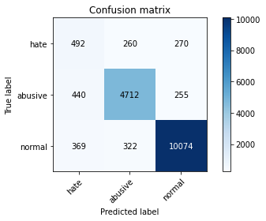

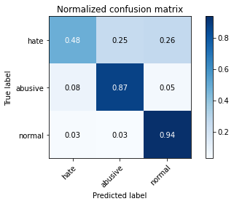

precision recall f1-score support

hate 0.38 0.48 0.42 1022

abusive 0.89 0.87 0.88 5407

normal 0.95 0.94 0.94 10765

accuracy 0.89 17194

macro avg 0.74 0.76 0.75 17194

weighted avg 0.90 0.89 0.89 17194

average eval_loss: 0.36178506171590713, accuracy: 0.8885657787600326

training 5 epoch...

1196.173663854599 seconds used......

5 training finished! average train loss: 0.9979438307050539

total clf loss: 276.4971049576998 total adv loss: 108.46982816694072

evaluating...

Confusion matrix, without normalization

[[ 460 298 264]

[ 388 4782 237]

[ 363 381 10021]]

Normalized confusion matrix

[[0.45009785 0.29158513 0.25831703]

[0.07175883 0.8844091 0.04383207]

[0.03372039 0.03539248 0.93088713]]

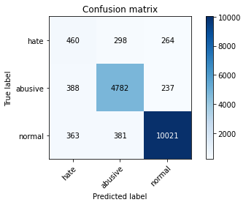

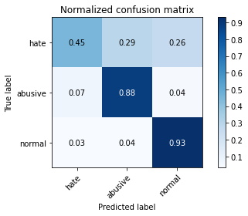

precision recall f1-score support

hate 0.38 0.45 0.41 1022

abusive 0.88 0.88 0.88 5407

normal 0.95 0.93 0.94 10765

accuracy 0.89 17194

macro avg 0.74 0.76 0.74 17194

weighted avg 0.89 0.89 0.89 17194

average eval_loss: 0.40066275561748205, accuracy: 0.8876933814121205

training 6 epoch...

1197.219303369522 seconds used......

6 training finished! average train loss: 0.8055110495220706

total clf loss: 238.5276325829327 total adv loss: 86.0189439530368

evaluating...

Confusion matrix, without normalization

[[ 419 309 294]

[ 338 4828 241]

[ 298 382 10085]]

Normalized confusion matrix

[[0.40998043 0.30234834 0.28767123]

[0.06251156 0.89291659 0.04457185]

[0.0276823 0.03548537 0.93683233]]

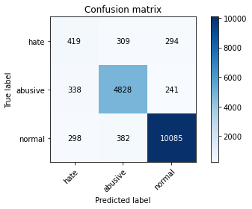

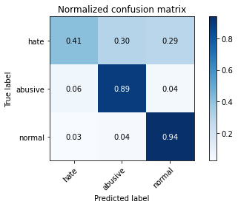

precision recall f1-score support

hate 0.40 0.41 0.40 1022

abusive 0.87 0.89 0.88 5407

normal 0.95 0.94 0.94 10765

accuracy 0.89 17194

macro avg 0.74 0.75 0.74 17194

weighted avg 0.89 0.89 0.89 17194

average eval_loss: 0.4321430505058447, accuracy: 0.891706409212516

training 7 epoch...